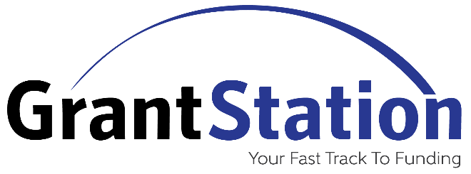
Do you struggle to identify new funding sources?
Does the lack of time limit your ability to submit grant requests?
Do you have a grants strategy?
As a member benefit, you can purchase full membership access to GrantStation for just $75, a 90% saving off the regular price of $699.
GrantStation provides tools to find new grant sources, build a strong grantseeking program, and write winning successful proposals to fund your organization’s mission!
Subscribe to GrantStation Today at a 90% Discount

Learn More about GrantStation
We are pleased to offer a subscription to GrantStation as a benefit of membership to help your organization find local, statewide, and national funding opportunities to fund your mission! To watch a full tour of this valuable benefit, click here.
GrantStation is the premiere suite of online grant research resources. Search their thousands of carefully researched profiles of private, government, and international funding opportunities, in addition to using the variety of grants research, writing, and management tools and resources to enhance your grant writing and development strategies. This service is available to our members for only $75.00, saving up to $624.00/year for your organization. To learn more about GrantStation, click here.
Check out additional free resources provided by GrantStation:
• GrantStation’s Insiders (weekly newsletter filled with grant information)
• GrantStation’s Tracks to Success (longer, in-depth articles)
• GrantStation’s GS Insights (shorter blog-style posts)

